Steps to create BDC recording for XD01

1. Go to SM35. Click on the Recording button.

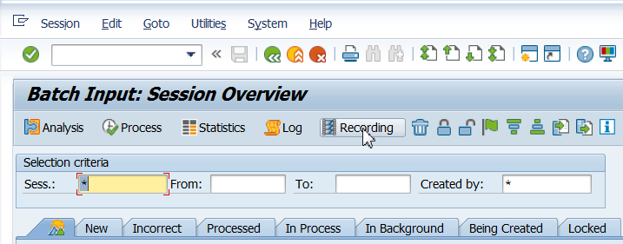

1. Click on New Recording.

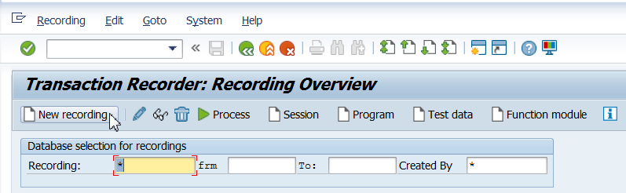

1. Enter details as shown below. And click on Start recording

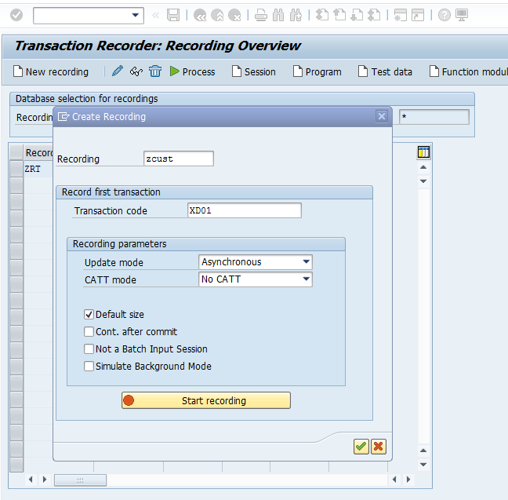

1. Enter the details as shown and press enter

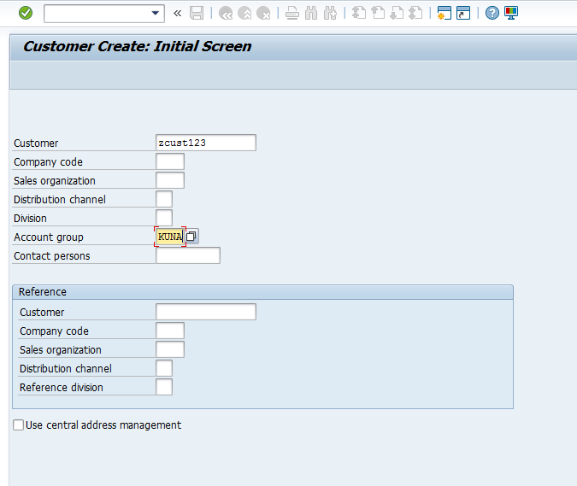

1. In the next screen, enter the mandatory details of the customer with valid values as shown below

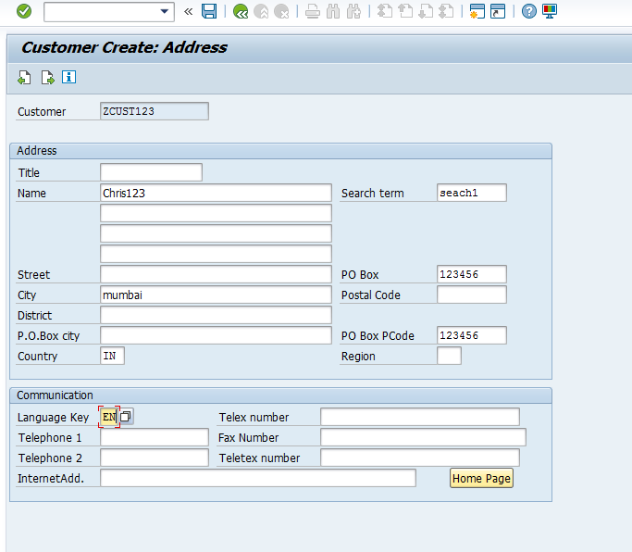

6) Then click on Save.

7) Below screen appears. Click on save and then Back button 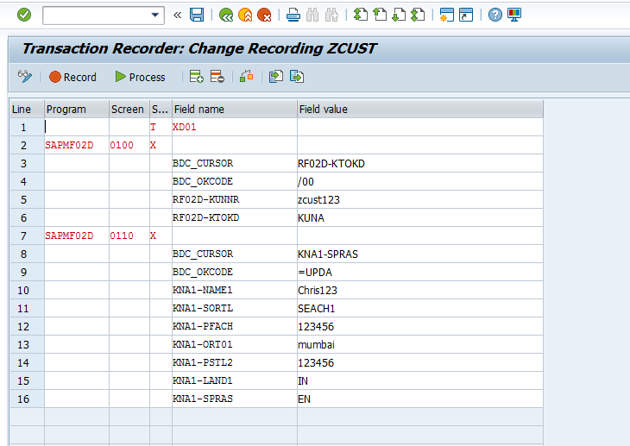

8) The recording is created ZCUST.

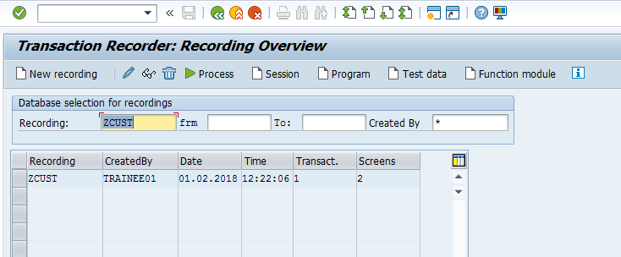

9) Select the recording created and click on Program

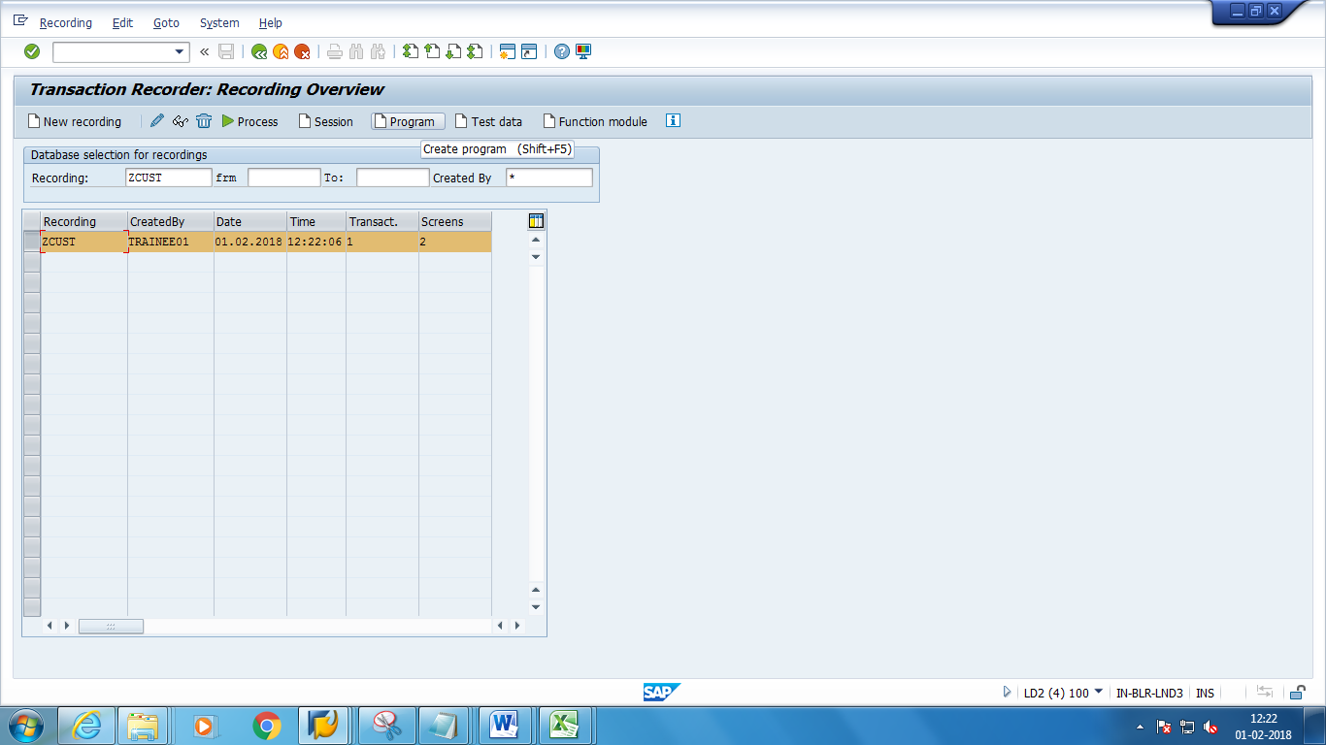

10)Give a suitable name to the program. Select transfer from recording and click on Continue.

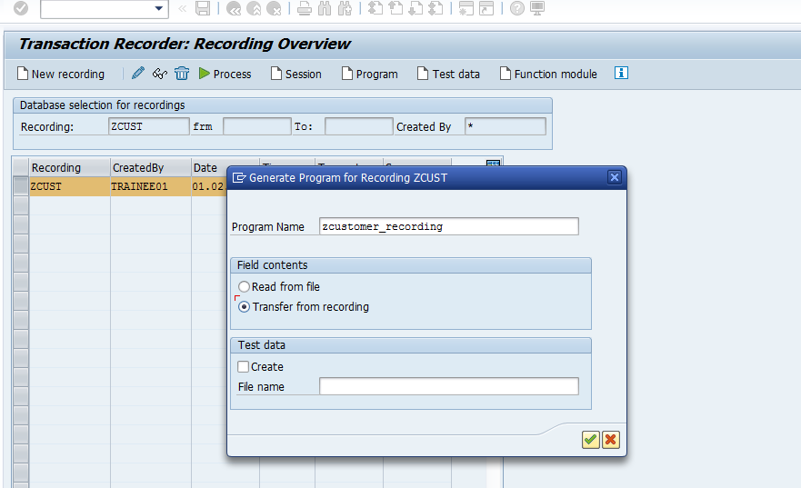

11)Click on source code

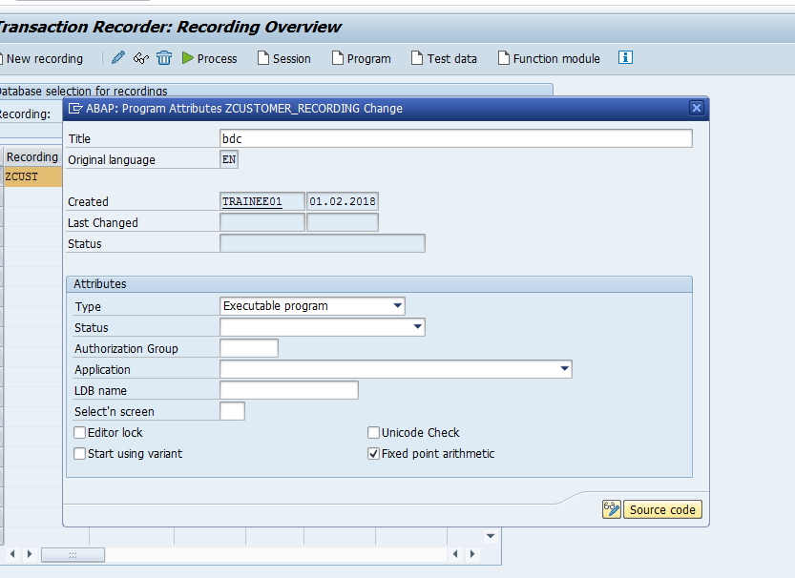

12)Save the program in local package .The code of recording is ready.

